

**Semester One Examination 2018**

**Question/Answer Booklet**

**MATHEMATICS**

**METHODS UNIT 3**

**Section Two:**

**Calculator-assumed**

Student Name: _____________________________________

Teacher’s Name: _____________________________________

**Time allowed for this section**

Reading time before commencing work: ten minutes

Working time for paper: one hundred minutes

**Material required/recommended for this section**

**To be provided by the supervisor**

This Question/Answer booklet

Formula Sheet (retained from Section One)

**To be provided by the candidate**

Standard items: pens(blue/black preferred), pencils(including coloured), sharpener, correction tape/fluid, erasers, ruler, highlighters

Special Items: drawing instruments, templates, notes on two unfolded sheets of A4 paper, and up to three calculators approved for use in the WACE examinations.

**Important note to candidates**

No other items may be taken into the examination room. It is **your** responsibility to ensure that you do not have any unauthorised notes or other items of a non-personal nature in the examination room. If you have any unauthorised material with you, hand it to the supervisor **before** reading any further.

**Structure of this paper**

|  |  |  |  |  |  |
| --- | --- | --- | --- | --- | --- |
|  | Number of questions available | Number of questions to be attempted | Working time (minutes) | Marks available | Percentage of exam |
| Section One  Calculator—free | 9 | 9 | 50 | 52 | 35 |
| **Section Two**  **Calculator—assumed** | **13** | **13** | **100** | **96** | **65** |
|  | | | |  | 100 |

**Instructions to candidates**

1. The rules for the conduct of Western Australian external examinations are detailed in the *Year 12 Information Handbook 2018.* Sitting this examination implies that you agree to abide by these rules.
2. Answer the questions according to the following instructions.

Section Two: Write answers in this Question/Answer Booklet. Answer **all** questions.

**Show all your working clearly.** Your working should be in sufficient detail to allow your

answers to be checked readily and for marks to be awarded for reasoning. Incorrect

answers given without supporting reasoning cannot be allocated any marks. For any

question or part question worth more than two marks, valid working or justification is required to receive full marks. If you repeat an answer to any question, ensure that you cancel the answer you do not wish to have marked.

It is recommended that you **do not use pencil**, except in diagrams.

1. You must be careful to confine your responses to the specific questions asked and to follow any instructions that are specific to a particular question.
2. Spare pages are included at the end of this booklet. They can be used for planning your responses and/or as additional space if required to continue an answer.

* Planning: If you use the spare pages for planning, indicate this clearly at the top of the page.
* Continuing an answer: If you need to use the space to continue an answer, indicate in the original answer space where the answer is continued, i.e. give the page number. Fill in the number of the question that you are continuing to answer at the top of the page.

1. The Formula Sheet is **not** handed in with your Question/Answer Booklet.

# Section Two: Calculator–Assumed 96 marks

This section has **thirteen (13)** questions. Attempt **all** questions. Write your answers in the spaces provided.

Spare pages are included at the end of this booklet. They can be used for planning your responses and/or as additional space if required to continue an answer.

* Planning: If you use the spare pages for planning, indicate this clearly at the top of the page.
* Continuing an answer: If you need to use the space to continue an answer, indicate in the

original answer space where the answer is continued, i.e. give the page number. Fill in the

number of the question(s) that you are continuing to answer at the top of the page.

Working time: 100 minutes

**Question 10 (5 marks)**

A sector of a circle has area K, given by 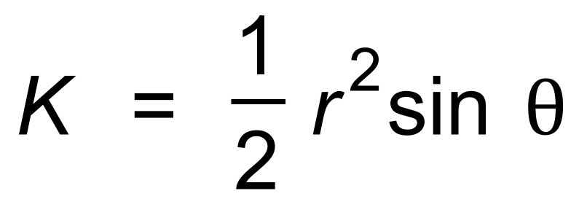, where r is the radius of the circle,

and θ is the central angle.

(a) Use the incremental formula to approximate the increase in K, as θ changes from

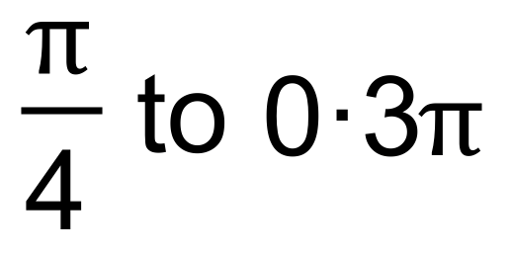in a circle of radius 4 cm. (3 marks)

(b) Determine the exact increase in K and hence determine the percentage error in your approximation from (a). Give your answer to one decimal place. (2 marks)

**Question 11 (7 marks)**

A curve has equation 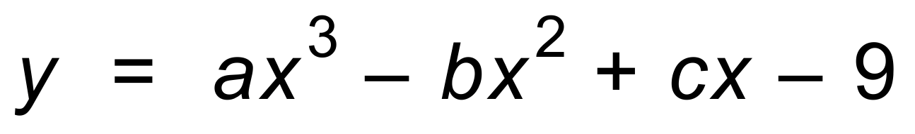.

There is a stationary point at (−3, 0).

There is a point of inflection at 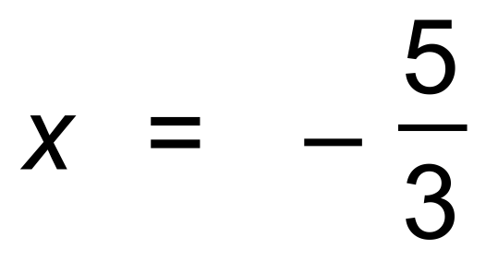.

Determine a, b and c. Show your working. (7 marks)

**Question 12 (6 marks)**

A function f has f ′(x) = 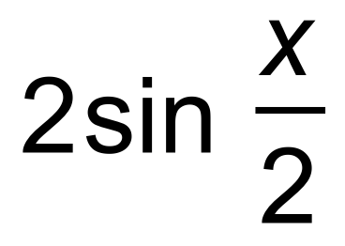.

(a) Determine the equation of f given that it passes through the point ( 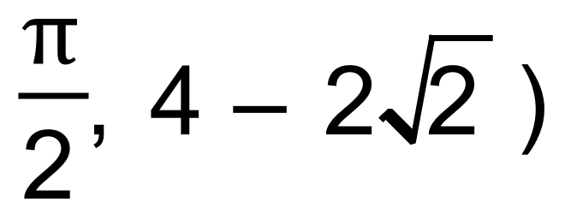. (3 marks)

(b) State the next value of *x* where the graph will have the same height (ie. 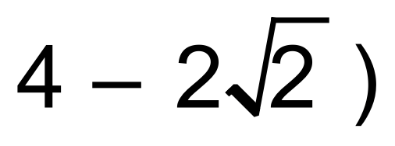.

Explain your reasoning. (3 marks)

**Question 13 (4 marks)**

The exponential series can be expressed as:

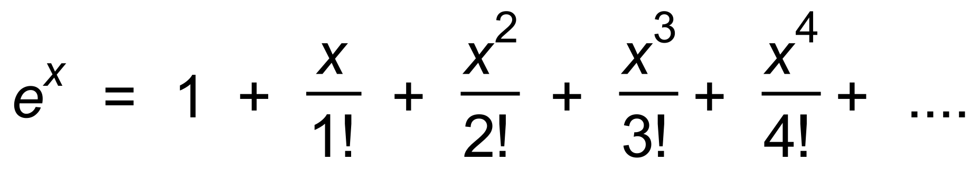 

(a) Use the first five terms of the series to evaluate e as a fraction. (2 marks)

(Hint: e = e1)

(b) Use the series to show that the derivative of ex is ex. (2 marks)

**Question 14 (6 marks)**

A function *M* (*x*) has 

A stationary point occurs at (6, 1).

(a) Calculate the value of k. (2 marks)

(b) Determine the value of the y-intercept on the graph of M. (4 marks)

**Question 15 (15 marks)**

75% of adults in a certain town graduated from high school.

(a) Thirty adults are randomly selected using the council records of the town.

(i) Calculate the probability that twenty five of these adults graduated from high school. State the probability distribution, and any parameters associated with that distribution.

(3 marks)

(ii) Given that at least twenty five graduated, find the probability that more than

twenty eight graduated. (3 marks)

(b) How many adults need to be randomly selected so that the probability that at least

ten graduated is at least 99%? (3 marks)

The Smith family consists of eleven people. Five of the Smiths graduated from high school.

(c) (i) If three of the Smiths attend a concert together, find the probability that at least

one of them graduated from high school. (3 marks)

(ii) If Peter and Sally are part of this family, find the probability that one, but not both of them,   
 graduated from high school. (3 marks)

**Question 16 (6 marks)**

(a) . (2 marks)

Hence, or otherwise,

(b) determine the points of intersection of  (2 marks)

(c) The graphs of  are drawn below. Determine the area of shaded   
 region. (2 marks)

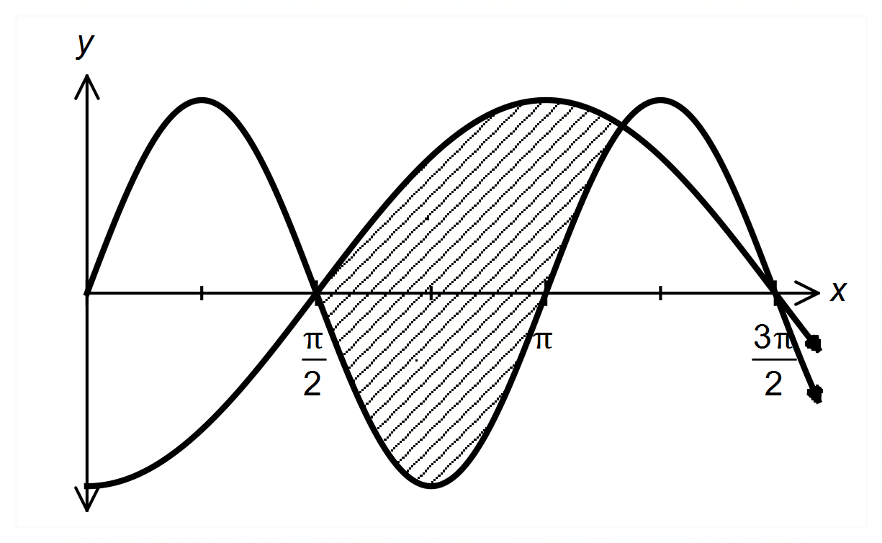

***Q*uestion 17 (5 marks)**

Consider the function 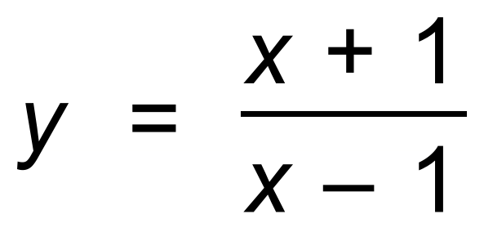

(a) Determine the *x*−intercept(s) of the function. (1 mark)

(b) (i) Determine 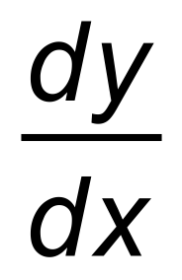. (1 mark)

(ii) Prove the conjecture; “This function has no turning points.” (1 mark)

(c) (i) Determine 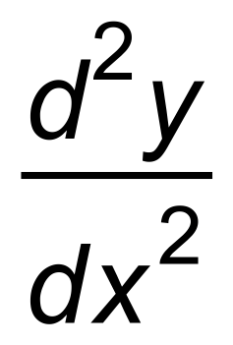 . (1 mark)

(ii) Prove the conjecture; “This function has no points of inflection.” (1 mark)

**Question 18 (13 marks)**

A particle is undergoing rectilinear motion. The velocity of the particle is given by

 Displacement is in metres.

(a) Determine the particle’s initial velocity. (1 mark)

(b) Calculate when the particle is stationary. (3 marks)

(c) (i) Determine an expression for the acceleration. (1 mark)

(ii) Hence, or otherwise, determine when the velocity is a minimum. (2 marks)

The particle has a displacement, *x* metres, from the origin O on the line.

It is initially at the origin.

(d) Determine the displacement when *t* = 3. (3 marks)

(e) Determine the distance travelled in the first 3 seconds to the nearest cm. (2 marks)

(f) Explain why the answers to (d) and (e) are different. (1 mark)

**Question 19 (6 marks)**

A forest fire is estimated to be spreading at a rate of 5% per hour. The area *A*, in ha, covered by the fire

at any time t, in hours since the fire was discovered, is defined by 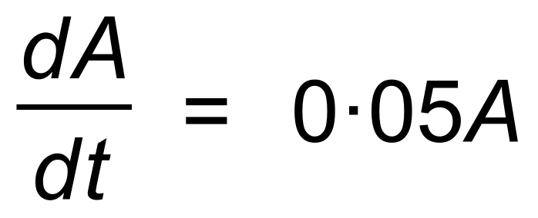.

At the moment of discovery, the area covered was 0.6 ha.

(a) What will be the area of the fire ten hours after it was discovered?

Give your answer correct to two decimal places. (3 marks)

(b) When would the fire cover an area of 5 ha?

Give your answer to the nearest hour. (3 marks)

**Question 20 (10 marks)**

Consider *f* where 

(a) Determine:

(i) *f* ′(*x*). (1 mark)

(ii) *f* ′′(*x*). (1 mark)

(b) State the exact maximum value of *f* over the given domain.

Prove it is the maximum using the second derivative test. (4 marks)

(c) Identify any points of inflection over the domain. Give the exact answer. (4 marks)

**Question 21 (4 marks)**

A long gas pipe is closed, but gas continues to flow out. The rate of flow 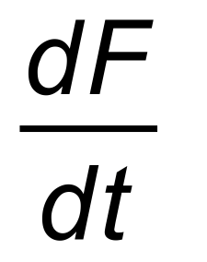, in litres per second,

is given by 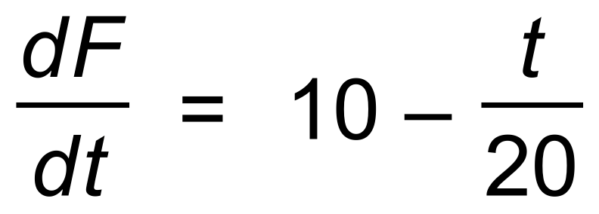.

(a) What is the initial rate of flow? (1 mark)

(b) How many seconds does it take till the flow stops? (1 mark)

(c) How much gas flows in total after the pipe is closed? (2 marks)

**Question 22 (9 marks)**

A drop of oil is spreading on a glass surface. The region covered is circular in shape,

and the radius, *r* cm, of the circle is given as a function of time, *t* seconds.

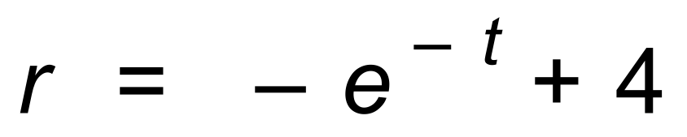

(a) Find the rate at which the radius is increasing when:

(i) *t* = 4. (2 marks)

(ii) *t* = 5. (1 mark)

(b) Use your knowledge of exponential functions and its graph, or derivatives,

to determine when the radius is increasing at its fastest rate. (2 marks)

(c) At what rate is the area of the circle increasing when *t* = 4? (4 marks)

**END OF QUESTIONS**

**Additional working space**

Question number(s): ……………………

**Additional working space**

Question number(s): ……………………

**Additional working space**

Question number(s): ……………………

WATP acknowledges the permission of the School Curriculum and Assessment Authority in providing instructions to students.